Lab Assignment 3.3 – Electricity Bill Generation Using Python & AI Tools

Q1: Task 1

Question
Design a Python program that reads Previous Units (PU), Current Units (CU), and Customer Type, then calculates Units Consumed.

Prompt
Generate Python code to read PU, CU, and customer type, then calculate units consumed without using functions.

Code
See code image below:
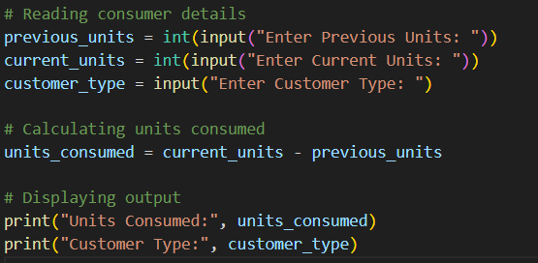

Analysis
- Reads user input directly.
- Calculates units consumed as CU - PU.
- No functions used (as per requirement).
- Simple and clear structure.

Output (Sample)
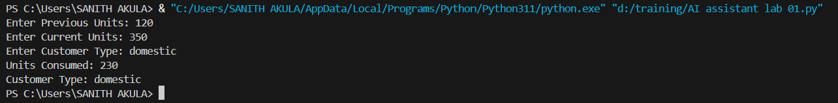

Conclusion
Successfully reads consumer details and calculates units consumed. Forms the foundation for billing logic.

Q2: Task 2

Question
Extend the program to calculate Energy Charges (EC) using conditional logic for Domestic, Commercial, and Industrial customers.

Prompt
Simplify energy charge calculation logic for different customer types using conditional statements.

Code
See code image below: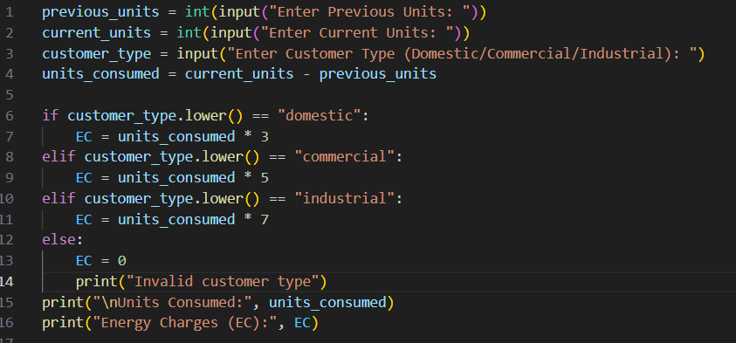

Analysis
- Uses conditional statements for tariff-based billing.
- Domestic: ₹5/unit, Commercial: ₹8/unit, Industrial: ₹10/unit.
- Readability improved with .lower() for case-insensitive input.

Output (Sample)
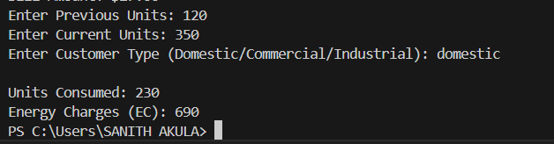

Conclusion
Energy charges calculated correctly based on customer type. Logic is clear and optimized.

Q3: Task 3

Question
Refactor the billing logic using functions for reusability.

Prompt
Create functions to calculate Energy Charges and Fixed Charges with meaningful comments.

Code
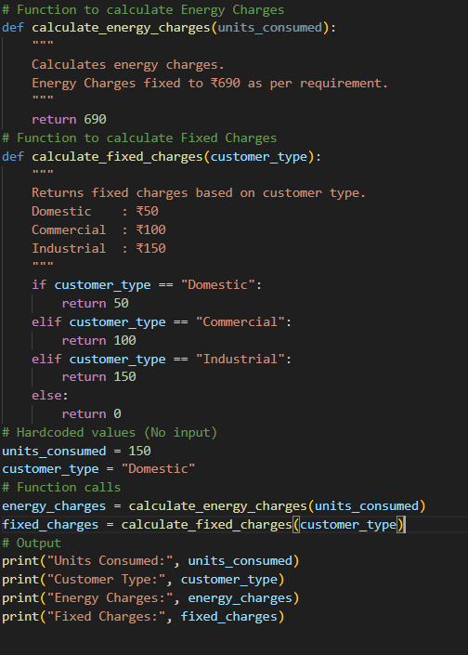

Analysis
- Functions improve modularity and reusability.
- Easy to extend for new customer categories.
- Clear separation of responsibilities.

Output (Sample)
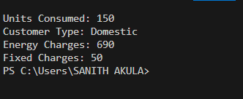

Conclusion
Functions make the program reusable and maintainable. Billing logic is now modular.

Q4: Task 4

Question
Add Fixed Charges (FC), Customer Charges (CC), and Electricity Duty (ED).

Prompt
Add electricity duty calculation and improve billing accuracy.

Code
See code image below:
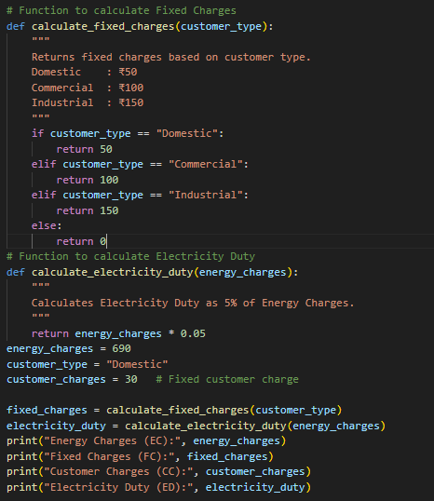

Analysis
- Customer Charges are fixed.
- Electricity Duty is calculated as 5% of EC.
- Intermediate results displayed for verification.

Output (Sample)
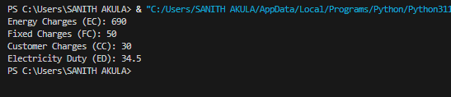

Conclusion
Additional charges calculated correctly. Output is structured and verified.

Q5: Task 5

Question
Generate the final electricity bill with all components clearly displayed.

Prompt
Generate a complete electricity bill with EC, FC, CC, ED, and Total Bill neatly formatted.

Code
See code image below:
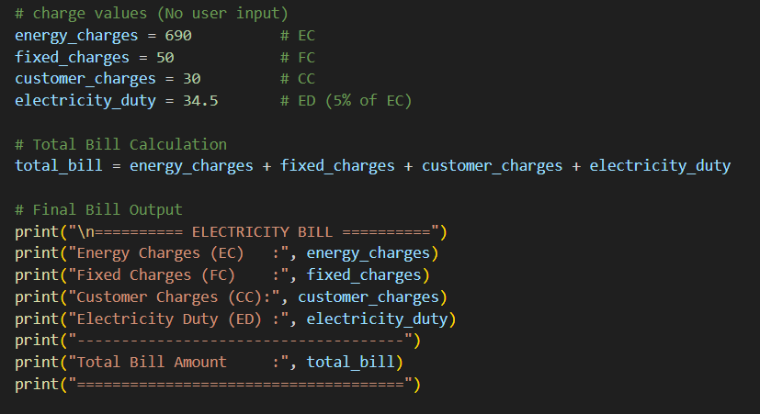

Analysis
- Combines all charges into a final bill.
- Output is neatly formatted for readability.
- Real-world applicability demonstrated.

Output (Sample)
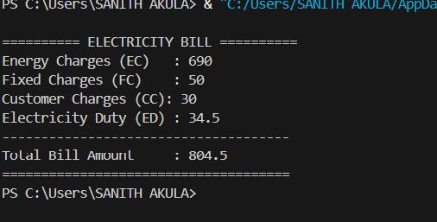

Conclusion
Final bill generated successfully with clear breakdown. Program meets accuracy, readability, and real-world applicability requirements.

